|  |  |
| --- | --- |
|  | |
|  | |
|  |  |

|  |  |
| --- | --- |
| Publication type: |  |
| Publication number: | ACC |
| Title: |  |
| Subject: |  |
| Issue: | 2.1.1 |
| Publication date: | 17 December 2014 |
| Total number of pages: |  |
| Author: |  |
| Quality Control: |  |

Table of contents

Page #

References 5

Introduction 6

About the Operating Manual 6

Safety instructions 7

Revision history 7

1. Introduction 8

2. Installation and settings 8

2.1 Downloading 8

2.2 Settings 8

3. The program 10

3.1 Alarm mimic 11

3.1.1 Colors and icons 13

3.1.2 Alarm values and setpoints 15

3.2 Instrument Mimic 16

Figures

Figure 2‑1: Seagull HD Icon 8

Figure 2‑2: Seagull HD Settings 9

Figure 2‑3: Color Palette modes 9

Figure 3‑1: Alarm mimic (default) 10

Figure 3‑2: Instrument mimic 11

Figure 3‑3: Selecting alarm station 12

Figure 3‑4: Warning and inhibited 13

Figure 3‑5: Alarm icons 14

Figure 3‑6: Setpoints and actual value 15

Figure 3‑7: Alarms extra information 15

Figure 3‑8: First start up instrument mimic 16

Figure 3‑9: Instrument choices 17

Figure 3‑10: Field Overlay 17

Figure 3‑11: 1 instrument configured 18

Figure 3‑12: Fully filled instrument mimic 19

# 

**NOTICE**

**This document contains proprietary information.**

**No part of this document may be photocopied, reproduced or translated into another language without the prior written consent of   
Imtech B.V.**

References

[1] ACC-NavVision-Operators-Manual v2.1.2

Introduction

A Programmable Logic Controller, PLC or Programmable Controller is a digital computer used for automation of electromechanical processes, such as control of machinery on factory assembly lines, amusement rides, or light fixtures.

Unlike general-purpose computers, the PLC is designed for multiple inputs and output arrangements, extended temperature ranges, immunity to electrical noise, and resistance to vibration and impact. Programs to control machine operation are typically stored in battery-backed-up or non-volatile memory. A PLC is an example of a hard real time system since output results must be produced in response to input conditions within a limited time, otherwise unintended operation will result.

FT NavVision integrated a PLC in the program itself to make it easier to implement programs for FT NavVision.

# Abbreviations list

OR Logic OR

XOR Exclusive OR

SELECT Select

TON Timer ON

TOF Timer OFF

TP Pulse Timer

R-TRIG Rising Trigger

F-TRIG Falling Trigger

MUL Multiply

DIV Divide

AD Add

SUB Subtract

LT Lesser Than

GT Greater Than

LE Lesser or equal

GE Greater or equal

EQ Equal

NE Not Equal

RS Reset before Set

SR Set before Reset

MAX Maximum

MIN Minimum

LIMIT Limit

CTU Up Counter

CTD Down Counter

CTUD Up-Down Counter

PULSE Pulse

About the Operating Manual

This manual contains the following sections:

* *Safety instructions* presents warning, caution and note information, which the user should pay attention to;
* *Installation and Settings* handles about all the necessary steps to install and setup the mobile NavVision version;
* *Program* handles about all the settings within the program itself;

For specific information on interfaces, but also in depth information on features, mentioned here or not, we refer you to their specific manuals which can be obtained through Imtech.

# Safety instructions

* This section provides only a summary of the safety requirements and notes in the following sections. To protect your health and prevent damage to the AM(C)S equipment or vessel, it is essential to read and carefully follow the safety instructions.*

The indications NOTE, CAUTION and WARNING have the following significance:



*NOTE:  
An operating procedure, practice or condition etc., which it is important to emphasize.*

**

*CAUTION:*

*An operating procedure, practise or condition etc., which, if not strictly observed, may damage AM(C)S equipment or crash NavVision software.*

* WARNING:*

*An operating procedure, practise or condition etc., which, if not carefully observed may result in personal injury or damage to the vessel.*

Revision history

Revisions issued since publication.

|  |  |  |  |
| --- | --- | --- | --- |
| **Issue** | **Date** | **Revision** | **Reason** |
| 1.0 | January 31, 2013 |  | initial release |
| 2.1.1 | February 6, 2015 | Decimus update | Divers |

# Softplc

## Introduction

As explained in the introduction the PLC is a programmable controller. It is used to make some logic controls that automate the operation and functionality of certain processes.

Normally this is programmed right into the PLC itself. The pro is that it can work stand alone. The con is that the programming of a PLC is time consuming and you need to know everything about the specific PLC. Especially when you need it to interact with FT NavVision© it becomes quit a hassle.

## General

A PLC (programmable logic controller) is an electronic device with a microprocessor that, on the basis of its various inputs, controls its outputs. A good example is the Wago PLC that we use often with our system. To make it easier to use and also to extend the range to use it with, we developed a soft PLC for FT NavVision. It is way beyond the scope of this manual to teach you how to program a PLC. That is knowledge that you need to have or that you need to acquire. The functionality is the same as any other PLC programming device.

## Basics

When you open Soft PLC for the first time you get an empty screen (see Figure 8‑1)

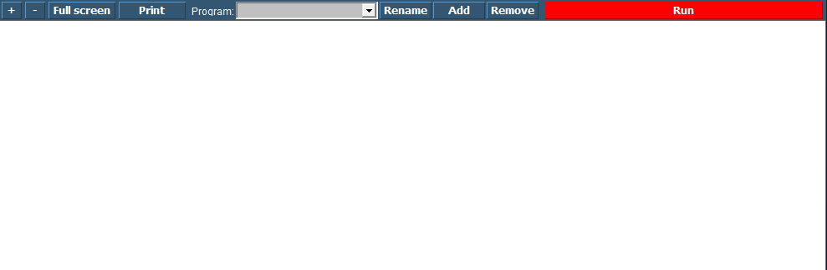

Figure 8‑1: Soft PLC

The following figures apply to the buttons on the screen:

|  |  |
| --- | --- |
| **Soft PLC Switch** | **Function** |
| +/- | Zoom in or out |
| Full Screen | Goto Fullscreen mode |
| Print | Print the Ladder Diagram |
| Program | Choose which PLC program you want to adjust by clicking the dropdown button |
| Rename | Rename the PLC program |
| Add | Add a new PLC program |
| Remove | Remove a PLC program |
| Run | Manually run or stop a specific PLC program |